Navigate to
TEMPLATE 1
TEMPLATE 2
TEMPLATE 3

TEMPLATE 1

Dear Team,

The time has come, we are ready to roll out Henchman and you will be part of it!

Definition of Henchman (noun) \ hench·​man \ Plural: henchmen
1. a trusted follower: a right-hand man
2. a squire or page to a person of high rank

[COMPANY NAME]-definition of Henchman
Your next best friend in contract drafting!

Henchwhat?
Henchman is a tool that links to our contract database and allows you to search for clauses and definitions from within the contract you are writing.

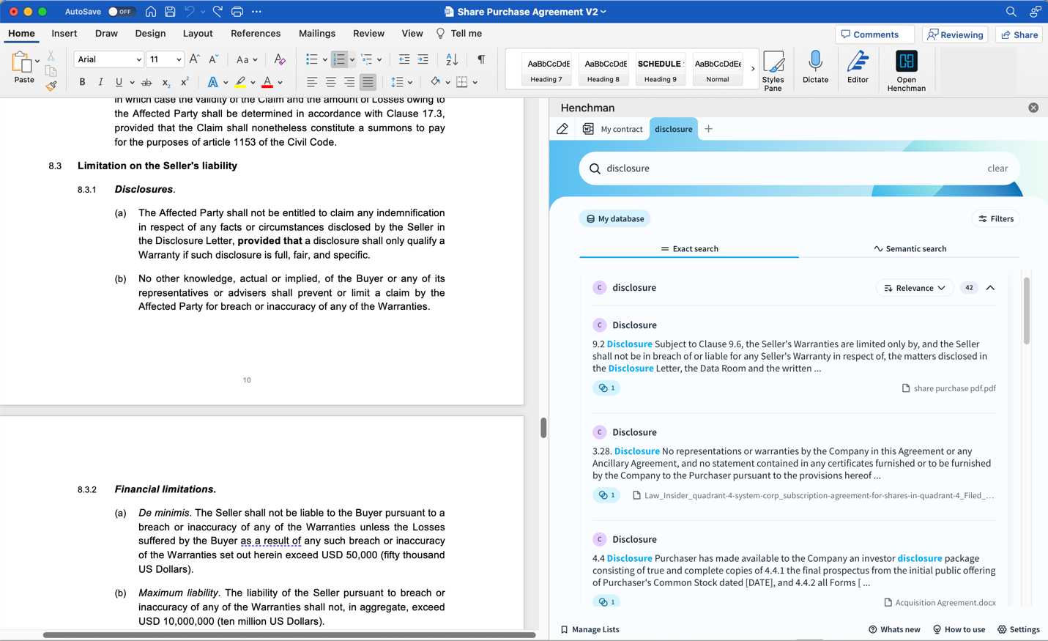

Remind me why that is useful?
We are sitting on a huge pile of existing knowledge from past files. However, it is not always easy to quickly find exactly what you need. So this tool allows you, in a few clicks, to find the wording of, for example, a non-compete clause that is more appropriate for the contract you are currently drafting.

OK, great. But I am an expert at searching our database and finding what I need.
In addition to faster searching, Henchman also gives you insights into which wording of certain clauses is used more frequently, or which clauses have recently become more trending (e.g. due to a change in legislation).

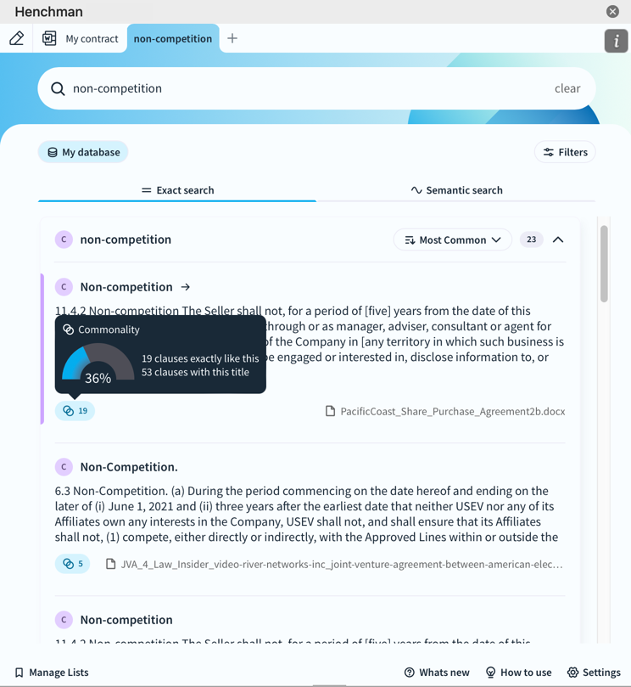

You can also see the textual differences straight away and, once you have chosen the right wording, Henchman will paste the text into your new contract with the correct formatting!

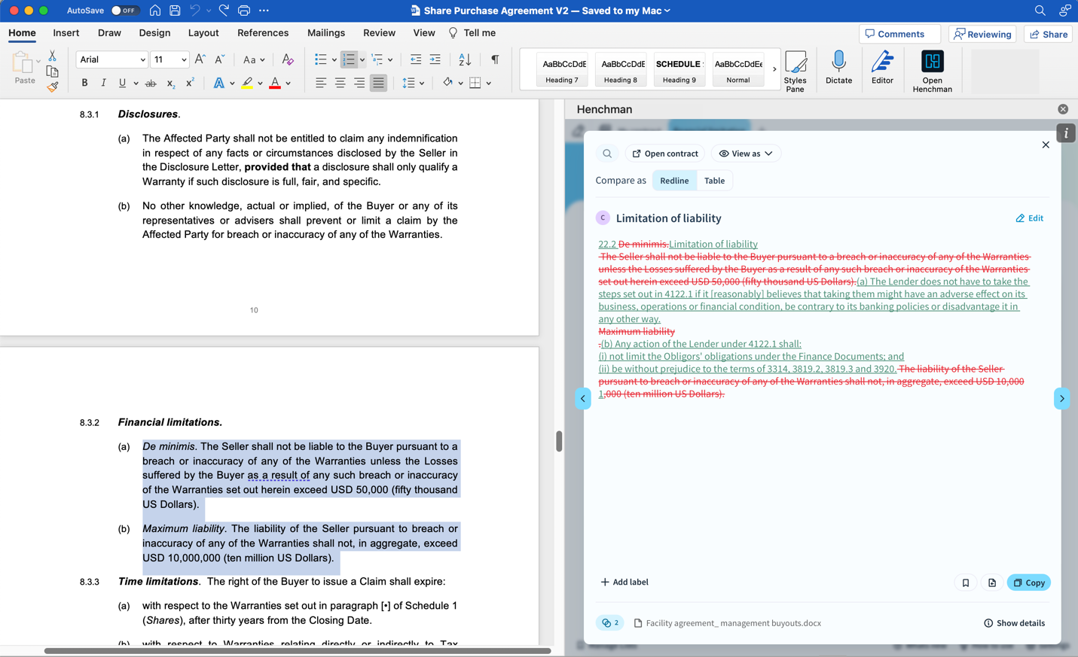

Wow, that sounds promising. But how does Henchman recognize all that?
Henchman makes use of smart technology that is able to process an entire database at lightning speed and is working day and night to include new contracts in subsequent searches as quickly as possible. So no manual input from us is required to identify clauses.

Und what if ich have to write ein contract in Deutsch?
The Henchman-minions are extremely language-savvy and can process searches in any language, even gibberish. However, what they cannot do is translate. If you are searching in German, you will only get search results in German.

Ok. Sounds like a must-have! Can someone come and install it for me?
On [DATE], we will organize an online training course. Just like driving a car, the tool is quite straightforward, but a few instructions are still welcome. So please accept the invitation and make sure to bring your laptop. During the session you'll be guided by Henchman to complete the initial set-up so you can get started right away!

Can't wait to have a look already?
Here’s a sneak peek.

Kind regards,

[YOUR NAME]

TEMPLATE 2
Hi,

We have been talking about Henchman contract drafting for a while now, the tool that will support your way of drafting and reviewing contracts.

We have reached the point where we are ready to roll Henchman out to all users and it will take place [DATE]

Agenda for the meeting (expected time is 45 minutes):
- Introduction: what is Henchman and how will it help Wikborg Rein?
- Training by [NAME], customer success manager at Henchman
- Time to make your first searches and get started right away
- Explain the ambassadors' role in the roll out process

We'll prepare everything from a technical perspective, and you will receive an invite to the Henchman-tool shortly.

You can activate your account by logging into Henchman via Office365 (see snip below - Word, right top corner, where you'll see the add-in). You will get help you during the meeting to get started if not already working.

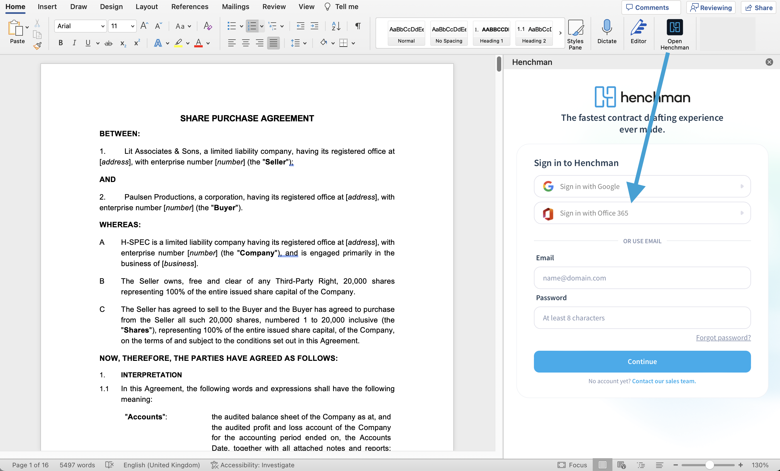

Looking forward to getting started so we can harvest the benefits!

Kind regards,
[YOUR NAME]

TEMPLATE 3
Dear Colleagues,

We’re inviting you to participate in the Henchman training session. During this session Henchman will provide full instructions and support to help us get the most out of Henchman .

The induction training will take place [DATE].

About Henchman:
Henchman is a Microsoft Word add-in that helps you draft contracts faster by retrieving previously written clauses from our contract repository and presenting these clauses to you within your trusted Microsoft Word environment.

Key features of Henchman:
1. Surface the precedent you need – in any language – from your document management system
Whether you’re just browsing through historical precedents or looking for a specific piece of information – we got your back. Henchman offers insights on commonly used clauses and definitions while advanced filtering methods let you narrow down to the exact contract type, date, party name, and more.

2. Enrich contracts with AI to achieve the ultimate drafting workflow
Use your own data more intelligently with the AI Clause Assistant, labels, and lists. Go beyond just finding what you need. Just like your ‘guilty pleasure’ playlist on Spotify, you can compile your favorite clauses & definitions into bespoke lists for future reference, share them with others, or onboard new hires more efficiently. As a cherry on top, our AI clause assistant helps you generate, translate, or update information using Large Language Models (LLM) & GPT.

3. Take the guesswork out of your drafting cycle
Save countless hours navigating complex contracts, making reviewing a breeze. No more skimming countless pages to review the fine print. Whether you’d like to quickly identify clause commonalities, surface similar clauses within your contract database, or leverage state-of-the-art capabilities to intelligently interact with your contracts – we’re here to make your review cycle as smooth as Dwayne ‘The Rock’ Johnson’s head.

If you have any questions please do not hesitate to contact me.

Kind regards,

[YOUR NAME]

